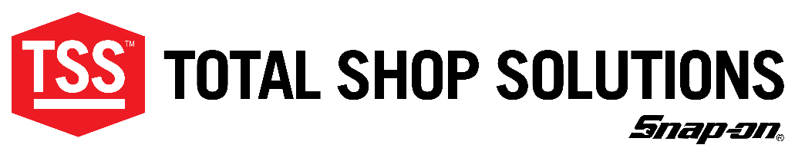

NEWS RELEASE For More Information, Contact:
For Immediate Release Erik Pedersson
+46 19 30 4021

erik.pedersson@snapon.com

Snap-on TSS Products to be Displayed at Autopromotec

Innovative John Bean Tru-Point ADAS System Available for Demonstrations

Conway, AR – May 17, 2022 – The John Bean® Tru-Point™ advanced driver assistance system (ADAS) calibration system will be one of the many Snap-on® Total Shop Solutions (TSS)™ innovative products on display at the 2022 Autopromotec show, May 25-28 in Bologna, Italy.

Tru-Point will be available for demonstrations at stand B28 in hall 19. A revolutionary ADAS calibration tool, Tru-Point is the only all-in-one solution on the market that allows shops to validate if the vehicle meets the OEM-required alignment specifications, as well as the proper target placement procedures. John Bean Tru-Point is equipped with top-of-the-line software technology and can be operated by one person, saving time and eliminating the need for extensive training.

In addition to Tru-Point, the stand will also feature products from other TSS brands, including Hofmann®, Blackhawk®, Cartec ®, Car-O-Liner®, Ecotechnics ®, Josam® and SUN® Collision. Many of the products will be available for hands-on demonstrations. Examples of showcased innovative equipment include:

- John Bean V3300 diagnostic wheel alignment system - The award-winning V3300 is designed for high-volume shops and provides immediate, precise alignments while its intuitive notification system helps to prevent errors before they result in a bad alignment.

- Hofmann geoliner® 609 and 770 Wheel Aligners - These versatile aligners provide advanced tire workshops with the same high level of innovative performance and precision that they have come to expect from Hofmann.

- Car-O-Liner CDR1 workstation will also be available for demonstrations at Autopromotec. The value-packed, all-in-one CDR1 contains all the equipment and materials needed to perform light-to-medium collision damage repair quickly and efficiently.

In addition, the new Induction Heater H4 PRO and Cartec New Generation Truck Brake Tester 420-BR will be showcased in TSS stand B28 in hall 19 at Autopromotec.

For more information about Autopromotec, visit www.Autopromotec.com.

About Snap-on Total Shop Solutions
Snap-on Total Shop Solutions is a family of Snap-on brands that brings together best-in-class automotive repair products. From wheel balancers, wheel aligners and diagnostics, to brake lathes, automotive lifts, and collision repair, Total Shop Solutions offers a broad range of innovative products to outfit your shop floor to ceiling.

# # #

